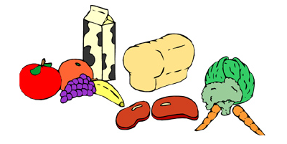
Sport Nutrition – The Basics
By Janelle Vincent, RD, IOC Dipl Sports Nutr (c)

Pre-Training/Competition
- Always eat before a training/competition, even when it’s first thing in the morning
- What you eat should help you stay hydrated, and make you feel ready to train/compete
- Eat foods that you like and that you have all the time, trying a new food before competition is not the best choice!
- Eat a meal 2-4 hours before
  - This meal should be:
    - High in carbohydrates (most of the meal)
    - Low in fibre and fat to prevent stomach upset and help with digestion
  - Have 2 cups of fluid (water, milk, sports drink, etc) with this meal
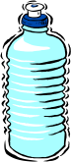
- 1 hour before the training/competition have a light snack (granola bar, fruit, etc)
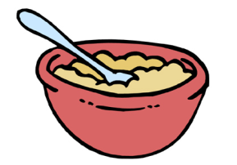

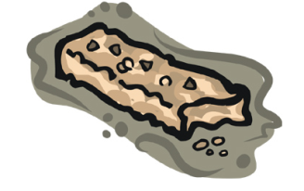
During the Training/Competition
- Stay hydrated
- Grab water and sports drinks
- Don’t wait until you are thirsty to drink
- Aim for 1 big gulp every 15-20mins, or as often as you can…and don’t spit it out!
- Take in fuel (carbs) as needed

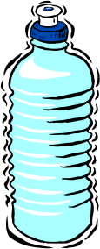

Post- Training/Competition
- Your body needs to re-fuel to be able to recover for your next training/competition
- Drink a lot of water/sports drinks
- Eat a snack 15-30 minutes after training/competition (fruit, chocolate milk, bagel, sandwich, Gatorade, granola bar, cereal, etc)
- Eat a ratio of carbs to protein of 4:1 (four times more carbohydrates than protein)
- Have a well-balanced meal within 2 hours following training/competition - remember to include all four food groups

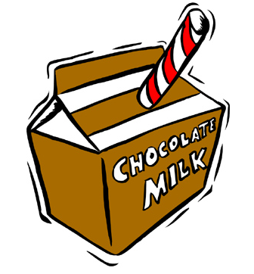
Training/Competition Meal Ideas

Pre-Training/Event
Meal Ideas
- Bagel with jam/honey, nut butter, fruit cup & yogurt
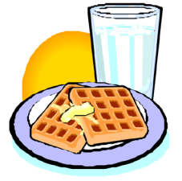
- Oatmeal/cereal, milk, dried fruit, juice
- Pancakes, small amount syrup, berries, milk/yogurt
- Grilled chicken sub, carrot sticks & dip, chocolate milk
- Pasta with lean meat/tomato sauce, salad, fruit salad, milk
- Lentil soup, roll, salad, soy/almond beverage
Snack Ideas
- Flavoured milk and banana
- Oatmeal cookies and milk
- Yogurt, fruit and granola
- Peanut butter and fruit wrap and milk
- Dry cereal, dried fruit and nuts/seeds (trail mix) & juice
- Sport Bar (1/2 – 1 bar) or Liquid Meal (Boost/Carnation/Ensure etc.)
Fluid Tip
- Aim for 2 cups of fluid 2-3 hours prior. Avoid pop.

During Training/Competition
Snack Ideas
Sport Bars
Whole Food Bars: Whole food bars, made from real food! Use for midday snack or during training/competition.
- Larabar
- Elev8Me!
- Simply Bar
- Rebar Energy
- Nature’s Path
- Source Salba
Moderate Protein Bars: Can be used during training/competition.
- Zone Perfect
- Genuine Protein + Express

- Banana
- Orange slices
- Apple wedges
- Fruit leathers
- Cereal bars
- Sports bars (see box)
Fluid Tip
- Aim for 2 gulps of fluid every 15-20 minutes
- Water
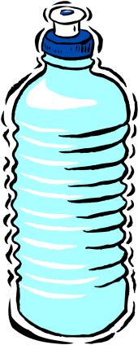
- Sports Drink

Recovery Snack following Training/Competition
Snack Ideas
Sport Bars
High Carb: Use for a quick recovery between events.
- Clif Bar
- PowerBar Sport
- PowerBar Harvest

- Homemade oatmeal cookies and chocolate milk
- Berries and yogurt with granola
- Low fat muffin and milk
- Cereal and dried fruit mix and boxed juice
- ½ banana and chocolate milk
- Tortilla with Nutella and banana
- Sports bars (see box)
Fluid Tip
- Hydrate to help with recovery – water, flavoured milk, sport drink, juice etc.

Between Training/Competition (days with two or more back-to-back events)
Short Breaks (< 2hr)
Longer Breaks (2-3 hr)
- lean meat sandwich
- juice & bagel/muffin
- yogurt, fruit, cereal
Small Meal (3 hr)
- vegetable soup, lean meat sandwich, milk, & fruit
- Rice, chicken, steamed veggies, yogurt, & juice
- Sports Bar

- Honey/jam sandwich
- Fruit – fresh/canned/pureed
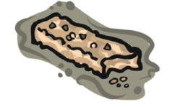
- Plain or chocolate milk
- Fruit yogurt or Liquid yogurt drink
- Cereal bar & juice box
- Cereal/dried fruit mix
- Sport drink or diluted fruit juice
Fluid Tip
- Aim for 2 gulps of fluid every 15-20 minutes
- Avoid pop

Post-Event (following last event of the day)
Meal Ideas
- Lean meat sandwich/sub, veggies, milk, oatmeal raisin cookie, fruit
- Egg, cheese, and ham English muffin, juice
- Soup and sandwich
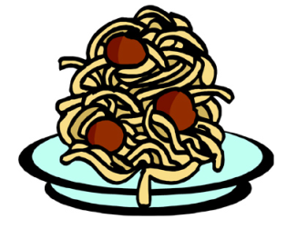
- Thick crust pizza with lean meat, veggie topping, milk, fruit
- Hot/cold cereal, milk, banana, juice
Snack Ideas
- Cereal or fruit bar, milk/yogurt
- Bagel, nut butter, fruit spread, milk/juice
- Yogurt, fruit and cereal
- Sport bar, chocolate milk
Fluid Tip
- Hydrate to help with recovery – water, flavoured milk, juice etc.

Athlete’s Food Record

When you eat a serving of food from a food group, check the box under the meal you ate it at.

 | Meal/  Snack  #1 | Meal/  Snack  #2 | Meal/  Snack  #3 | Meal/  Snack  #4 | Meal/  Snack  #5 | Meal/  Snack  #6
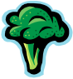
Super

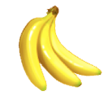
Foods

8-14+
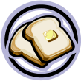
Energizers
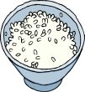
8-14+
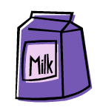
Bone
Builders
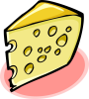
3-4
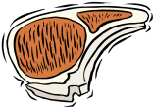
Muscle
Repair
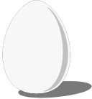
2-3
Fluids

* All meals and snacks count, even recovery snacks
* Bring fluids and snacks to all events

